Ch 12. Powdery Mildew
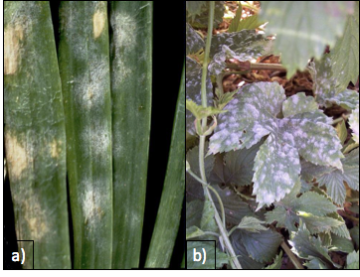
Figure 12.1. Leveillula taurica growing on onion plant (a) and Podosphaera macularis growing on hops (b). The fungi themselves can look pretty similar, even under microscopic observation.

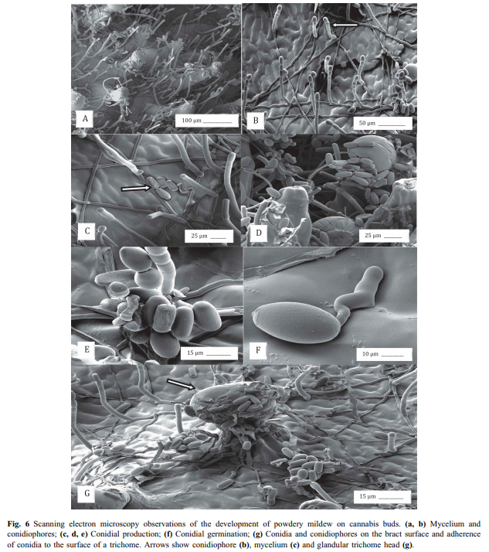
12.2 SEM of powdery mildew conidia germinating on Cannabis buds. (Punja 2018)
Taxonomy
Kingdom: | Fungi
Phylum: | Ascomycota
Class: | Leotiomycetes
Order: | Erysiphales
Family: | Erysiphaceae
Genus: | Golovinomyces; Podospheara ; Leveillula
Species:  unresolved | Golovinomyces ambrosiae (Syn. G. cichoracearum, G. spadiceus). Podosphera macularis; Leveillula taurica

Introduction
One of the most ubiquitous and well known of the fungal pathogens on Cannabis are the powdery mildews. Caused by multiple organisms, this dreaded pathogen first manifests itself as a white, cottony growth that begins to form on the top surface of leaves. Once conspicuous on the leaves, the spores of this fungus are likely to be everywhere in your grow, whether it is indoors or out.
However, there are various effective treatments that can eliminate this fungus (depending on the stage and degree of severity) and practices that can be used for preventing this fungus from getting established in the first place. Most growers have experience dealing with this fungus at one point or another. In many regions, PM is so common that one should assume that there are always going to be mildew spores in the air, unless you are growing in a filtered indoor space. Even then, starting with an assumption that you have spores in your garden will help you to develop and maintain a solid Integrated Pest Management program (IPM).
Just like everything else in the Cannabis industry, there are some clear misconceptions about these fungi that can be misleading and very confusing. To start with the confusing common names, powdery mildews and downy mildews are not the same thing and should not be treated in the same way. Downy mildew, caused by an oomycete rather than a fungus, is less commonly seen on Cannabis crops, though growers should still be aware of the pathogen and the symptoms associated with it (see “Chapter 16: Leaf Spot Diseases” for more information on Downy Mildews).
Elucidating the species of powdery mildews affecting Cannabis will assist cultivators in controlling the disease. Most species of powdery mildew are host specific and have limited alternate host ranges on which to hide from farmers whose crops may be affected (Table XX). Definitive knowledge of the species and pathovars affecting Cannabis will help us prevent cross-contamination from susceptible neighboring host plants. However, no matter which powdery mildew species you have any applied treatments will be the same.

Table XX. Alternative host range of powdery mildew species affecting Cannabis.
Species | Alternate hosts
Golovinomyces ambrosiae (Syn. G. cichoracearum, G. spadiceus). | Asteraceae (Acanthospermum, Ambrosia, Aster, Blainvillea, Chrysogonum, Coreopsis, Dahlia, Eupatorium, Gerbera, Helianthus, Lagascea, Laggera, Leucanthemum, Mauranthemum [Chrysanthemum s. lat.], Melampodium, Parthenium, Telekia, Tithonia, Xanthium, Zinnia), Fabaceae (Crotalaria), Malvaceae (Abelmoschus),Polygonaceae (Persicaria), Solanaceae (Solanum), and  Verbenaceae (Verbena).
Podosphera macularis | Humulus (americanus, lupulus, scandens [=japonica]), Moraceae
Leveillula taurica | Probably a species complex with unresolved host ranges:  Amaranthaceae (Amaranthus, Celosia, Gomphrena), Apocynaceae (Rauvolfia, Vinca) Aristolochiaceae (Aristolochia), Asclepiadaceae (Asclepias, Calotropis, Stapelia, Vincetoxicum), Bombacaceae (Asansonia, Bombacopsis), Burseraceae (Commiphora), Campanulaceae (Asyneuma, Phyteuma), Caricaceae (Coccinia, Cucumis, Cucurbita) Datiscaceae (Dattisca), Dipsaceae (Scabiosa), Grossulariaceae (Ribes), Daeodoraceae (Anigozanthos), Hydrophyllaceae (Phacelia), Hypericaceae (Hypericum), Linaceae (Linum, Reinwardtia, Malvaceae (Abelmoschus, Abutilon, Hibiscus), Martyniaceae (Martynia), Myrtaceae (Chamaelaucium), Oleaceae (Olea), Onagraceae (Clarkia Epilobium), Orobanchaceae (Leptorhabdos, Odontites), Plantaginaceae (Digitalis, Phlox, Polemonium), Polygonaceae (Polygonum, Rumex), Primulaceae (Samolus), Rosacea (Reseda), Salvatoraceae (Salvatora), Scrophulariaceae (Scruphularia), Tiliaceae ( Corchorus), Verbenaceae (Caryopteris, Lippia, Verbena).

There are accumulating reports identifying Golovinomyces cichoracearum sensu lato as the powdery mildew affecting Cannabis in Canada and France based on ITS sequencing (Pépin et al, 2018; Punja, 2018; Rodrigues et al, 2015) and G. spadiceus has been identified from Kentucky (Szarka et al, 2019). Unfortunately G. cichoracearum sensu lato is poorly defined phylogenetically, likely comprising many cryptic species.
There is also evidence that the ITS sequence alone does not adequately discriminate among closely related Golovinomyces species (Punja, 2018). These mixed and unclear results are not all that surprising given the fact that Cannabis has been illegal to grow and most scientists did not have the ability to work with this plant. Also, molecular fingerprinting has only been around since the mid-1980’s, with many organisms yet to be sequenced.
Macpartland et al. 2000 documented two species of powdery mildew infecting Cannabis: Leveillula taurica and Podosphaera macularis. However, under current nomenclature systems Podosphaera macularis is host restricted among Humulus species only (Uwe Braun, personal communication). This is contradicted by recent cross infectivity experiments, at least in greenhouse environments ( Weldon 2018). Most recently P. macularis has been found to cause natural infections on Cannabis plants in Oregon and Canada (Bates et al 2021, Punja et al 2021). Levieullula taurica was reported by Jaczewski, 1929, but has not been confirmed as a common cause of powdery mildew among Cannabis recently.
A private lab also reported an unknown genetic isolate from Cannabis grown in the Northeast United States. They claimed a full genome sequence did not match any known Erysiphales in GenBank (a universal genetic depository for researchers), and that the northeast isolate was not a Golovinomyces (Medicinal Genomics).
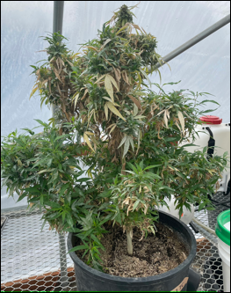
Figure 12.4. Host plant of Cannabis sativa being used to grow powdery mildew to inoculate future research projects for the development of powdery mildew controlling products. Since PM is obligate biotroph, researchers must keep PM alive on live Cannabis plants.

Powdery mildew is an obligate biotroph, meaning that it requires a host plant in order to complete its life cycle (live, grow, and reproduce). This characteristic makes obligate biotrophs incredibly difficult to study compared to saprophytic or necrotrophic fungi, since powdery mildews cannot be cultured in a petri dish or flask on nutrient media, rather they must be kept alive by growing the pathogen on a susceptible host plant. As noted before, powdery mildew can be extremely difficult to identify, even with a microscope. The keys that are available use very small, difficult to see features to distinguish among powdery mildew fungi. A major diagnostic feature for the identification of powdery mildew anamorphs (asexual state) are characteristics of the appressorium following conidia germination. Teleomorph identification can take advantage of the often unique, and beautiful, ornamentation on the sexual fruiting bodies (chasmothecia). However, chasmothecia are rarely formed on Cannabis.
Accurate identification of many anamorphs is very difficult by diagnostic characters alone, and benefits from molecular techniques. Molecular techniques such as polymerase chain reaction (PCR) have enabled great strides in genetic sequencing, however these approaches also have drawbacks and are not widely available outside of academia and specialized private labs. Among fungi, the inter transcribed spacer (ITS) and ribosomal RNA of the large subunit (LSU rRNA) have often been used for phylogenetic analysis. Increasingly groups of genes are used to develop a consensus phylogeny, since single gene phylogenies based on the ITS sequence have been shown to be prone to error.

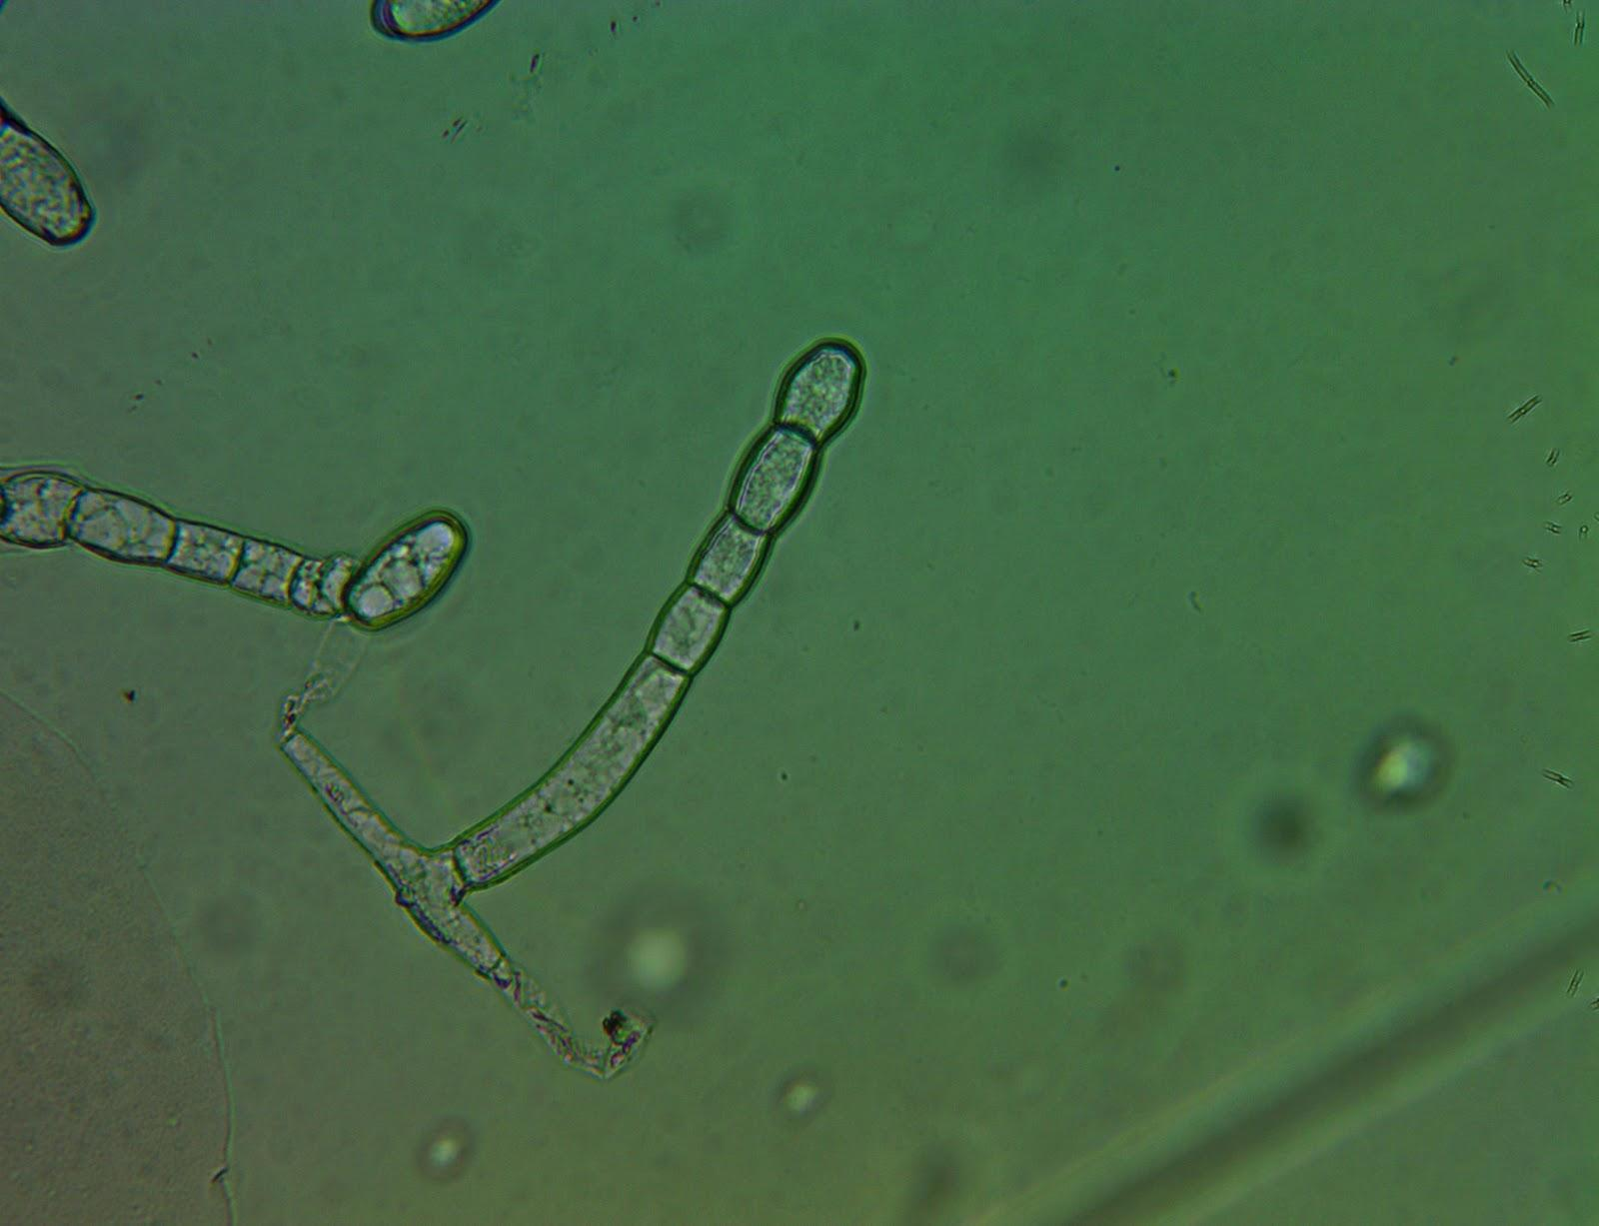
Figure 12.5. Powdery mildew (Golovinomyces ambrosiae) conidiophore found on Cannabis leaf surface grown in a greenhouse in Oregon. Tape mount at 40x

Like many other groups of fungi, the taxonomy of the Erysiphales (powdery mildews) is in a state of flux. As our understanding of the evolutionary relationships of each discrete species improves, names are changed and species are moved among taxonomic groupings so that our taxonomic system increasingly represents underlying phylogenetic relationships. There are certainly more than one species of Erysiphales affecting Cannabis which may have differing geographical distributions and host ranges. Definitive knowledge of the identity and geographic range of powdery mildew affecting Cannabis, as well as alternate host-plant species, will advance the ability of cultivators to effectively control pathogen outbreaks. It is likely that at least one of the PM species affecting Cannabis cultivators in North America has a relatively broad host range.
An occasional debate in the Cannabis industry is whether or not powdery mildews are systemic. All the scientific evidence that we have seen, in combination with direct observation and knowledge of fungal biology, points to powdery mildew not being systemic. For a pathogen to be systemic, the pathogen would be able to infect one point on the plant (say a leaf) and then travel within the plant to infect other, distant plant parts. Powdery mildews typically form superficial infections restricted to the epidermal tissue. Some species are known to penetrate into the deeper palisade layers of the mesophyll. Some form localized infections into the petiole. But no powdery mildew in the entire Order Erysiphales are known to form extensive systemic infections within their respective plant host (Uwe Braun, personal communication).
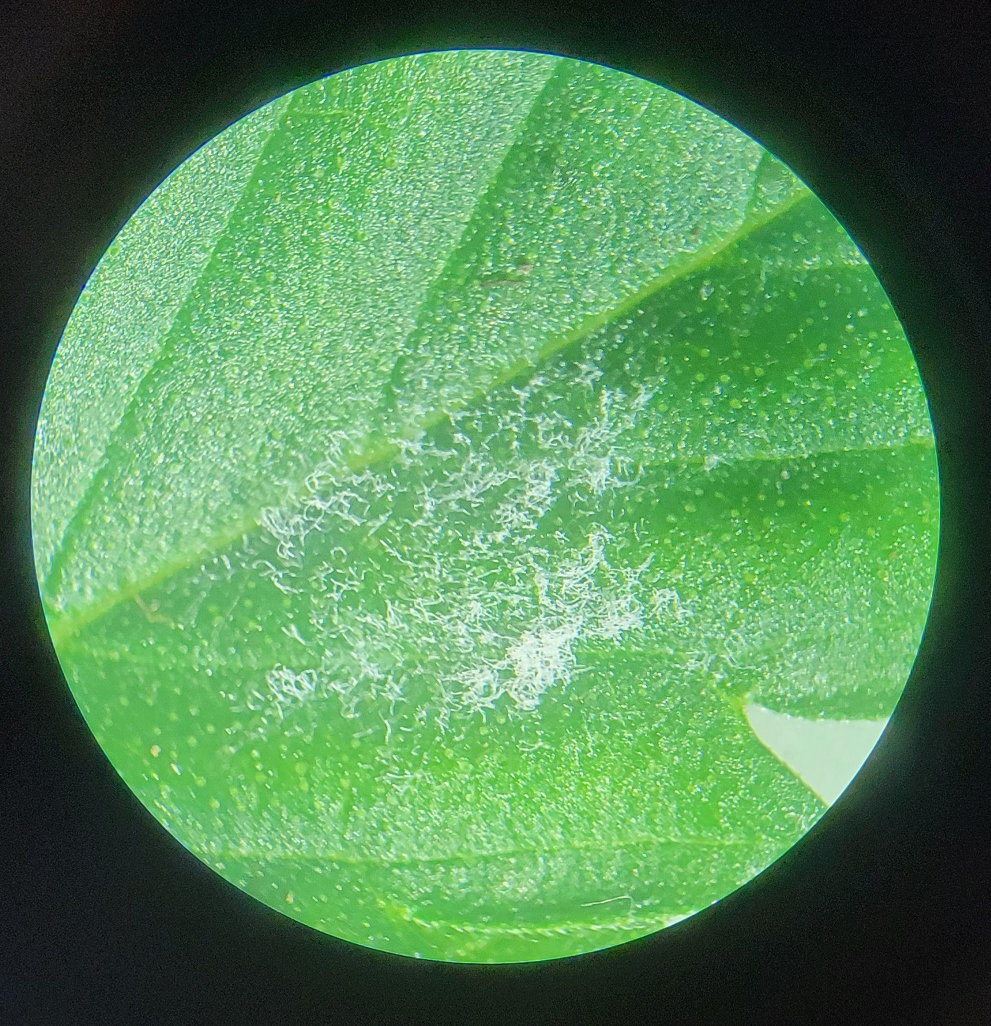
Figure 12.6. Golovinomyces ambrosiae on a Cannabis leaf (dissecting scope XXXx, Cottage Grove Oregon 2021)
Farmers often observe large outbreaks on individual plants, fail to take clean clones from plants with infection elsewhere, or experience vertical, seed borne transmission; all of these suggest systemic infection. However, powdery mildews prolifically produces spores. The spores are then wind and animal dispersed, quickly traveling from one part of a plant to another or even throughout an entire garden. Therefore, once you spot the fluffy white mass growing on a plant, the fungus has most likely already begun to produce spores and it is almost guaranteed that there are other PM spores in the air. Seemingly systemic infections are actually the coalescence of individual colonies, each representing an infection point.
The fact that powdery mildew colonies almost always manifest as circular growths indicates they are individual colonies. This is analogous to fairy rings or colonies in petri dishes, which expand outward from an original inoculation point in every direction. Seed borne transmission of powdery mildew is possible, however it is exclusively (or nearly so) due to conidia on the seed surface, rather than an infection within the embryonic plant body. Because of this, seed borne infections of powdery mildew can be prevented by surface sterilizing seed prior to planting.

Biology & Life cycle
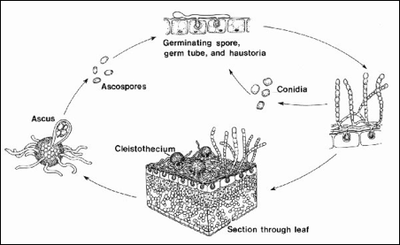
Figure 12.7. Life cycle of a typical powdery mildew fungus. Asexual reproductive structures (conidia) are commonly seen on Cannabis. Recently sexual fruiting bodies of G. ambrosiae have been observed on Cannabis (Szarka et al. 2019). For other species of PM affecting Cannabis it may be that sexual structures may only form on alternate hosts or may have lost their sexual stage completely, persisting solely as fungi imperfecti. Alternatively, it may simply be that humans have not yet documented the occurrence of chasmothecia on Cannabis in all instances in which they may occur.

The life of a powdery mildew begins, like other ascomycete fungi, with a spore (either a sexual ascospore or an asexual conidium).When a spore lands on an area that is suitable for growth it will form a germ tube, a primary hyphae strand. The hyphae will grow from stored energy, but quickly need access to nutrients for survival.
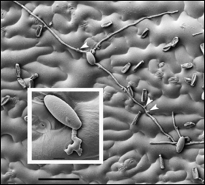
Figure 12.8. Scanning electron micrograph of germinating powdery mildew conidia on leaf surface. Arrows point to the appressoria forming a penetration peg to infect plant tissue (Micali et al. 2010).

As an obligate parasite, PM must invade host tissue in order to siphon off nutrition. In order to gain access to host tissue, a specialized structure, called an appressorium, capable of exerting high amounts of pressure onto a concentrated point on the plant surface is formed by the developing fungi (Fig. 5). Often appressoria will form above inherent weaknesses, such as directly above a stomata or at the meeting point between two epidermal cells. While a pressure peg exerts force on the leaf surface the hyphae also releases enzymes that degrade the cuticle and cell walls of the plant tissue it is trying to penetrate. If successful, the puncture peg will form a hole into the plant body through which it extends a specialized hypha termed, haustorium.
Haustoria are lobed, prong-like projections able to penetrate the cell wall of plant cells (though not the membrane). The haustorium becomes engulfed by the plant's plasma membrane, allowing the fungus to absorb nutrients from the plant in the extracellular space between the plant cell membrane and wall. A specialized, convoluted membrane is formed by the fungus within the space (called the extrahaustorial matrix) along the plant membrane in order to maximize the surface area across which it may absorb nutrients (Micali et al. 2010). The fungus now has a source of nutrients to continue to grow and mature and translocates this food throughout its entire body -including the epiphytic portions.
The mycelium can now form secondary hyphae which continue to spread endophytically to nearby plant cells, as well as epiphytically over the leaf surface and use appresoria to create new points of invasion through which the fungus may access more areas of the plant body. After a short period of vegetative growth in a conducive environment, the fungus will produce conidiophores. Erysiphales are capable of producing conidia in great numbers.
Until recently, only the asexual state had been observed on Cannabis. Szarka et al, however, observed G. spadiceus readily forming chasmothecia in autumn on Cannabis in Kentucky (2019). Podosphera macularis is also capable of forming chasmothecia on cannabis plants (Weldon et al, 2020). Chasmothecia (or formerly, cleistothecia), are the sexual structures formed by members of the Erisyphales (Fig. 6). They appear as dark, spherical structures made of tightly interwoven hyphae with simple appendages. Inside the chasmothecia are multiple-many asci, each containing 8 ascospores (Fig. 7). Once the asci and ascospores are mature, the chasmothecium will burst and the spores will be released and dispersed into the environment.
The usual lack of chasmothecia on Cannabis among may indicate a biological impediment to fruiting body formation when the most common powdery mildew species infects Cannabis. If so, there may be alternate hosts on which the sexual stage of the pathogen occurs. Alternatively, these races affecting Cannabis may have lost their sexual state, or such asexual populations are isolated from compatible mating types and only exist exclusively as an anamorph locally.
This is the current state of the P. macularis population in the Pacific Northwest, where currently only the MAT1-1 type is known. Currently there is a quarantine targeting hop powdery mildew in the United States to prevent the introduction of the MAT1-2 mating type into the Northwest. The production of chasmothecia on Cannabis by P. macularis presents risk to the hop and Cannabis industries throughout the US by potentially facilitating the spread of sexual mating types into the PNW, which would be followed by a proliferation of pathovar genetic diversity (Weldon et al, 2020). Cannabis may also serve to move dangerous pathovars that are emerging in the PNW to new areas.

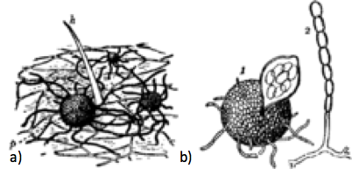
Figure 12.10. Podosphera macularis reproductive structures. Chasmothecia in the soil (a) and then a chasmothecia next to a conidiophore producing conidia to the right (b).

Powdery mildew can overwinter in the form of this resistant chasmothecia structure. Thus they can lay dormant in your soils or fields and then when the environment is sufficient for growth, the chasmothecia will open and release spores into the wind. If the spores land on a suitable host, the spore will germinate, a germ tube will form and the life cycle begins again.

Prevention
There are a wide variety of treatments for powdery mildew, both at the store and in the literature, and everyone seems to have their own opinions on what works best at what time. The proverb that an ounce of prevention is worth a pound of treatment is especially true when it comes to fungal diseases. The best way to deal with PM is to never get it in the first place. This is accomplished by having a strong IPM program, including set scouting schedules and good cultural practices.
In general, PM species affecting Cannabis thrive in warm, humid, and poorly lit conditions. Anywhere from 60ºF to 85ºF and humidity levels above 75% will create the perfect habitat for these fungi (Amsalem et al. 2006). Crucially, variable humidity is necessary for the dissemination and subsequent germination of spores to create new infections (Dewey Scientific, Cannabis cultivation podcast 2021). Spores are able to spread during periods of low humidity and are able to germinate at high humidity. Higher light intensity is associated with reduced disease incidence, with the shaded interiors of canopies being most at risk for PM infection (Amsalem et al. 2006). Large swings in day/night temperature and humidity can exacerbate the issue with some PM species (Mahaffee et al. 2003).
Many growers clean out the interior of canopies by defoliating and removing plant tissue, believing increased airflow will reduce powdery mildew infections. While this may actually reduce infections, the practice is likely effective due to increased light penetration, rather than or in addition to a localized reduction in canopy humidity. However, some researchers have noted that after harvesting equipment goes through the field and agitates plant biomass, disease pressure is increased (Correll et al. 1988). Regardless, maintaining a canopy with good light penetration and airflow seems to reduce PM incidence and severity.
The different species of powdery mildews will have slightly different ecological niches and may respond differently to cultural controls. As the science progresses and the species causing disease in Cannabis are better understood, more specific measures can be taken to help control PM. For instance, alternate hosts may be a significant factor in maintaining a reservoir for PM innocula. Knowing what other plant species are capable of serving as alternate hosts for the relevant PM species will greatly assist growers in keeping the local area clear of PM.
Leveillula taurica can also cause PM on onions and several other common garden plants such as eggplant, tomato, peppers, and others. This species has only been documented in the western United States, as this species prefers slightly drier, warmer climates.
Podosphaera macularis commonly grows on hop plants, and has been frequently reported from the hop fields of Oregon and Washington (Mahaffee et al. 2003). This species prefers high humidity. A large swing in the daytime/nightime temperatures and humidity will also increase the chance of infection (Mahaffee et al. 2003).
Most PM species will produce conidia in great numbers, so it is very important to maintain daily scouting programs and preventative sprays if you are growing in conditions that are conducive to mildew growth. Once the white, powdery growths are detected, there are almost certainly going to be conidia all over your garden.
For preventative treatments, biological sprays and root drenches are recommended. A strong resident microbial community, both in your soil and in the phyllosphere (area surrounding leaf surface), has been shown to increase plants’ innate resistance to pathogens. Prophylactic treatment with compost teas have been shown to effectively reduce fungal diseases under field conditions (Weltzien, 1989). The logic here is that you will be inoculating the leaf surfaces with a growing community of healthy microbes. Many endophytic microbes are able to travel from the roots into aerial plant portions, so foliar sprays are not necessarily required to cause full-plant infection. Beneficial microbes act in myriad ways to reduce PM infections.
Biological sprays could be a compost tea, a mixture of effective microorganisms, or plant fermentations (Weltzien, 1989). Commercial products are available of Bacillus subtilis, Bacillus amyloliquefaciens, Lactobacillus species, Streptomyces lydicus, and many others. Most of these commercial and naturally occurring symbionts act similarly (pathogen niche occupation, and by activating plant ISR). However, some directly antagonize disease organisms by producing antifungal compounds or acting as hyperparasites (Romero et al. 2006).
Streptomyces lydicus is an example of a microorganism that impedes powdery mildew growth through chemical defenses. This soil dwelling actinobacterium (filamentous bacterium) produces many different novel metabolites. Some of these compounds that are excreted are antifungal and antibiotic in nature, and thus are very important in the agricultural and pharmacological industries.
Natamycin is one such anti-fungal compound produced by Streptomyces lydicus (Atta et al. 2012). This compound will bind to ergosterol in the plasma membrane of fungi and inhibit protein transport, thus starving fungal cells of key nutrients and components they need to continue living eventually leading to the death of the fungus (Welscher et al. 2008). Natamycin is a broad spectrum antifungal compound and will target any fungus that contains ergosterol in the membrane (Atta et al. 2012).
Strains of Bacillus subtilis have been shown to be effective at suppressing powdery mildews as well (Shoda, 2000). This is a very competitive bacterial species that is able to persist in harsh environments through the production of spores. In addition to being able to readily colonize leaf tissue, some B. subtilis stains produce myriad antifungal compounds including surfactin, fengycin, and iturin A or bacillomycin that enable this microbe to outcompete pathogens (Romero et al. 2007).
Other ways that biocontrol agents (BCA’s) are effective at reducing powdery mildew outbreaks is through the use of fungi that parasitize the pathogen targeted for elimination. In particular, Ampelomyces quisqualis is a hyperparasite on some powdery mildew fungi. A conidial suspension is typically prepared and then applied to infected plants. Once the conidia of the hyperparasite land on the PM, A. quisqualis conidia begin to germinate and invade the host tissue. This parasite will degenerate the host (PM) tissue by extracting nutrients from the host cytoplasm, thereby starving the pathogen (Kiss et al. 2004). The conidia, hyphae and sexual spores are all subject to invasion of the hyperparasite (Kiss 2003).
Use of A. quisqualis for biocontrol is limited by the obligate nature of the hyperparasite; at least some powdery mildew must be present for A. quisqualis to establish and repeated application of conidial solutions is required, however there have been successful reports of PM control among some crops (Gadoury). Further research is needed to determine the efficacy of using this biocontrol with Cannabis specifically.
A more widely proven antagonist of powdery mildew is Trichoderma harzianum (Elad et al. 1998). This BCA has several modes of fighting off pathogenic fungi. Trichoderma exhibits competition with PM for resources (food/light/space), produces antifungal compounds, acts directly as a hyperparasite of PM fungi, induces innate plant resistance, and can stimulate plant growth (Kiss et al. 2004). This BCA acts as a generalist (Naher et al. 2014), inhibiting the growth of a number of fungal pathogens.

Table 11.1. Common organic preventatives and treatments for Powdery Mildew that are acceptable for use on Cannabis. All sprays, even water, have some action by physically removing spores and hyphae from the plant surfaces.

Product | Active ingredient(s) | Mode of action
- Serenade  - Double Nickle | Bacillus subtilis  Bacillus amyloliquifaciens | - Direct competition  - Activates induced systemic resistance (ISR)
- GreenCure | Potassium bicarbonate | - Raise pH leaf surface  - Dries out mycelium due to osmotic potential
- Actinovate | Streptomyces lydicus | - Secretes antifungal compounds (natamycin)  - Direct competition
- Regalia | Raenoutria sachalinensis extract | - Activates induced systemic resistance (ISR)
- Elemental sulfur | Sulfur | - Interferes with several fungal life functions (e.g. spore germination)
- Bordeaux mixture | Copper sulfate and hydrated lime | - Copper ions inhibit spore germination, hydrated lime raises pH
- Neem Oil | Plant oils, azadirachtin and other terpenoids | - Antifungal compounds  - Physical barrier
- Dr. Zymes | Citric acid | - Unfavorable pH

Treatment
If preventative measures are not sufficient and symptoms of PM appear on leaf surfaces, there are still plenty of steps you can take to ensure minimum impact on your garden. The first step is to manually remove infected tissue. Spray the garden down with a high pH solution or elemental sulfur to limit spore movement and disrupt fungal growth before removing infected material. Researchers have shown that spraying the plants down, even if it is with just plain water, can reduce disease incidence (Jarvis and Slingsby 1977). Conidia do not do well when saturated in water (Perera 1972). Place infected leaves into a container and frequently disinfect your hands and shears as you perform this maintenance.
Perhaps one of the oldest treatments for powdery mildew comes from the vineyard growers of Europe (Martin, 1932). The Bordeaux mixture stems from the early 1900’s and is a mixture of copper sulfate and hydrated lime. This treatment is approved for use in organic production and is very effective at inhibiting fungal growth. The copper ion prevents conidia germination and the hydrated lime raises the pH of the leaf surface to a point that the fungus cannot tolerate (Somers, 1965). This is best used as a preventative treatment although has been shown to be effective as a contact fungicide, killing the fungus after it has gotten a foot hold.
Other common treatments include baking soda (sodium bicarbonate), potassium bicarbonate, elemental sulfur, neem oil, boron, or high silicon fertilizers (Bowen et al. 1999). There have also been reports of varying concentrations of milk being an effective treatment for the reduction of powdery mildew (Fig. 8)(Bettiol 1999, Crisp et al. 2006). Although no one is certain why milk is an effective treatment, researchers hypothesize it could be due to free radical production, antifungal fatty acid presence, or simply an osmotic imbalance (Crisp et al. 2006)
Different situations will determine which treatment will be most appropriate. For instance, you do not want to be spraying elemental sulfur on flowering plants, especially if they are destined for extraction. Doing so will result in a burnt rubber aroma (not in a good way) in the concentrated product. Using a cocktail of multiple ingredients or rotating products that have different modes of action seems to be a logical and effective way to treat infected plants. This way the fungus is less likely to develop a tolerance or resistance to any particular ingredient.
When possible, the environment of your space may be controlled to discourage PM growth. This could include raising your temperature and decreasing the relative humidity of your room, or increasing light intensity. Whole garden heat treatments (holding the garden at 100ºF for 2 hours) may reduce fungal growth (Perera, 1972). Ultraviolet light treatment systems can significantly reduce fungal inocula and subsequent disease (such as the CleanLight Pro or similar device).

Remediation
Powdery mildew affected flowers can be rinsed in water during harvest to minimize fungal load. Powdery mildews are not toxic or pathogenic to humans, though affected flowers are of lowered quality. Inhalation of high spore load of any fungi represents an allergen risk and are physically irritating to lung tissue Some forms of extraction may effectively remediate mold affected Cannabis (See Table 18.6).

